Retention Scheduler
Use Case Specification

Submitted to:

Asst. Prof. Ma. Rowena C. Solamo
Faculty Member
Department of Computer Science
College of Engineering
University of the Philippines, Diliman

Submitted by:
Aldrin “Yno” F. Simpao
David Relao
Neil Jonathan Joaquin

In partial fulfillment of academic requirements
for the course
CS 191 Software Engineering I
of the
1st Semester, AY 2014-2015
Revision Control

History Revision:
Revision Date | Person Responsible | Version  Number | Modification
9/28/14 | Yno | 1.0 | Initial Document;
9/29/14 | Yno | 2.0 | Added flow of events.
9/30/14 | Yno | 3.0 | Added flow of events diagrams.

Use-Case Name: Manage Events

Description: Overall event handler. A simple menu option where users are given the option to either create an event, edit an event or delete an event. Can be seen along view calendar events in the main menu.

Preconditions: NONE.

Flow of Events:
Scenario Name | Description
Scenario 1 (Basic Flow)  User wishes to add an event to his calendar. | The user clicks on the button “Create event”. User will then enter all the needed information (i.e. name of event, date of event, ). Please refer to the use case “Create event” for more information and to see the flow of this event.
Scenario 2  User wishes to edit an event. | The user wishes to make changes to an existing event. In such cases, the user will be redirected to the event information screen where the user can make the changes. This is also one of the submenus that can be seen after the Main menu “manage events” is clicked.
Scenario 3  User wishes to delete an event. | The user wishes to delete an event from the list of existing events and the calendar. In such cases, the user will be redirected to the list of all events that is different from the viewing methods. This is also one of the submenus that can be seen after the main menu “Manage events” is chosen.
Activity Diagram of the flow of events:
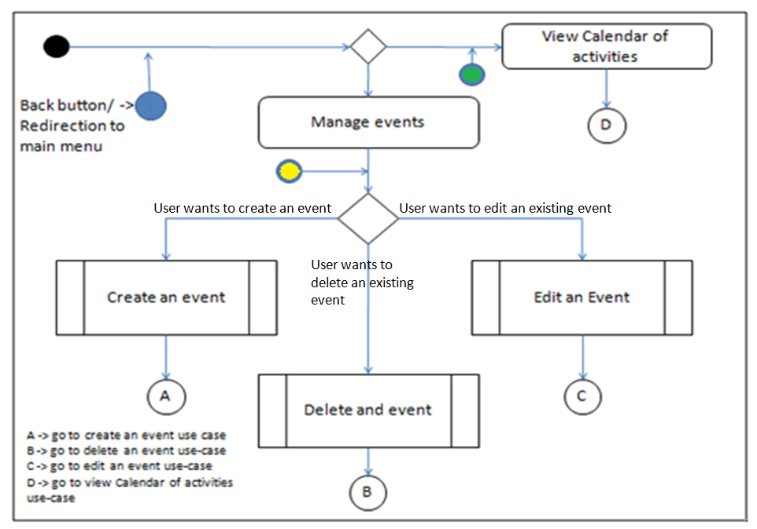
Postcondition: User selects one of the submenus. Otherwise, he will be given an option to go back to the main menu.

Relationships: Create an event
Delete an event
Edit an event.

Special Requirements:
None:

Use-Case Name: Create an event

Description: Adds an event to the calendar and the list of events. Can be seen after the button “manage events” is used. User will then enter all the information needed and then the event will be saved.

Preconditions: The event to be created is not yet present in the current events list.

Flow of Events:
Scenario Name | Description
Scenario 1 (Basic Flow)  User creates the event. | The user clicks on the button “Create event”. The user will then be redirected to a blank event information screen where the user can enter all the needed information such as the name of the event, the date of the event, the link to the slides and the link to the notes relevant to this event. The user can then save the event or go back
Scenario 2  User chooses to go back | The user will be redirected to the Manage Events submenu

Activity Diagram of the flow of events:
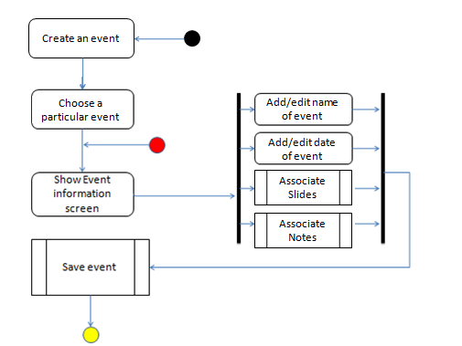

Postcondition: The user saves the event.

Relationships: Save an event.
Manage Events.

Special Requirements:
None.

Use-Case Name: Edit an event

Description: This lets the user to modify an existing event. In which case, the user will be redirected to event information screen where the user can change the name and date of the event. The user can also associate more or remove slides and notes to the event.

Preconditions: The event to be edited/modified is already present in the list of the events and the calendar.

Flow of Events:
Scenario Name | Description
Scenario 1 (Basic Flow)  User wishes to edit an event. | The user clicks on the button “Edit an event”. He is redirected to the event information screen (same as when you create an event). The user clicks a button the change one of the information.
Activity Diagram of the flow of events:
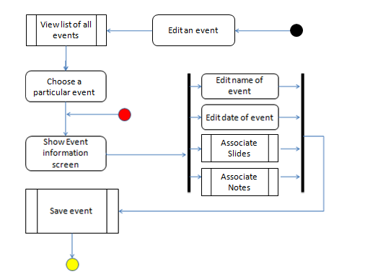

Postcondition: The user must save the event.
Relationships: Save an event.
Manage events.

Special Requirements:

None.

Use-Case Name: Save an event

Description: Adds an event to the calendar and the list of events. Can be seen after the button “manage events” is used. User will then enter all the information needed and then the event will be saved.

Preconditions: The user must have chosen to create an event or edit an event.

Flow of Events:
Scenario Name | Description
Scenario 1 (Basic Flow)  User entered all need information and associated slides and notes to the event. | The user clicks on the button “Create event”. User will then enter all the needed information such as the name of the event, the date of the event, the link to the slides and the link to the notes relevant to this event.
Scenario 2  User does not have any slides to associate with the event. | The user must have entered all the needed information but does not have any slides to associate to the event. The program will then continue to save the event. This is assuming that the user has associated a note to the event.
Scenario 3  User does not have any notes to associate with the event. | The user must have entered all the needed information but does not have any note to associate to the event. The program will then continue to save the event. This is assuming that the user has associated a slide to the event.
Scenario 4  User does not have any slides or notes to associate with the event | The user entered all the needed information but does not have anything to associate to the event. The program will handle this by saving the event still but giving a warning that the user did not associate any slides or notes to the event. In case the alarms are to set off already, the program will only display the name of the event.
Scenario 5  User does not have a name for the event. | The user entered the date of the event but did not input a name. The program will give a warning that the user did not enter a name. The event will not be saved unless the user enters a name for the event.
Scenario 6  User did not enter the date of the event. | The user entered a name for the event but did not include a date for the event. The program will give a warning that the user did not enter a date for the event. The program will also not include the event to the list of all events and the calendar until the user saves the event with a date.

Activity Diagram of the flow of events:
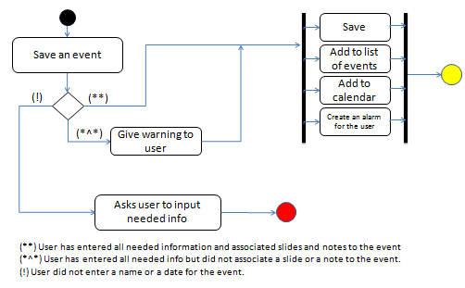

Postcondition: None.

Relationships: Create an event.
Edit an event.

Special Requirements:
1. Name of the event
2. Date of the event

Use-Case Name: Delete an event

Description: Removes an existing event from your scheduler. This also removes the event from the calendar of events and the list of all events. It is important that the event to be deleted must be existing.

Preconditions: Event to be deleted is an existing event

Flow of Events:
Scenario Name | Description
Scenario 1 (Basic Flow)  User has chosen what event to delete | The user then clicks a button beside the event in order to delete it. He will be prompted whether or not to continue he deletion wherein choosing yes will remove the event from the events list and the calendar.
Activity Diagram of the flow of events:
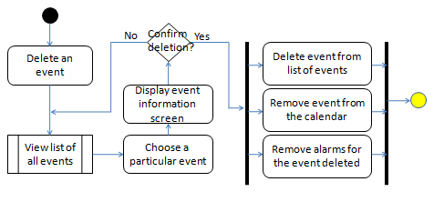

Postcondition: None.

Relationships: Edit an event.
Delete an event.

Special Requirements:
None.

Use-Case Name: View List of all events

Description: This displays all the events of the user in a list formatting. The events will be sorted in increasing order. This can only be viewed when the user is choosing an event to delete or edit.

Preconditions: The user has chosen either to edit an event or delete it.

Flow of Events:
Scenario Name | Description
Scenario 1 (Basic Flow)  The user want to either delete an event or to edit an event | The program will display the list of all events in ascending order – year, month, day and then by name. The current day will be emphasized for readability purposes. The names will then be clickable if the user does click on a particular event, the program will display the event’s information screen.

Activity Diagrams of the flow of events:

Postcondition: None.

Relationships: Delete an event.
Edit an event.

Special Requirements:
None.

Use-Case Name: View Calendar of events

Description: This displays all the events of the month. All the events shown are created by the user for the user. However, this does not display the alarms that will be set off before events. If the user has not created an event, it will only display a blank calendar.

Preconditions: None.

Flow of Events:
Scenario Name | Description
Scenario 1 (Basic Flow)  User wishes clicks on the View Calendar of events button | The program displays the events in a monthly calendar mode. The user can then either go into a weekly calendar mode, a daily calendar mode or go back to the main menu. In all cases, the program will display the events created by the user. Note that this viewing mode will not let the user edit events.
Scenario 2  User chooses another viewing mode (I.e. Weekly, daily) | The program will then display the events according the mode selected by the user. It will be the same as the other viewing options.
Activity Diagram of the flow of events:
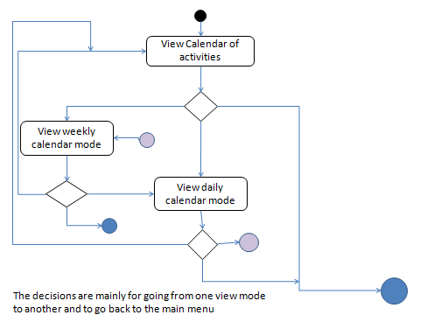

Postcondition: None.

Relationships: View events of the week.
View events of the day.

Special Requirements:
None.

Use-Case Name: View events of the week

Description: This displays all the events of the week. All the events shown are created by the user for the user. However, this does not display the alarms that will be set off before events. If the user has not created an event, it will only display a blank weekly calendar.

Preconditions: None.

Flow of Events:
Scenario Name | Description
Scenario 1 (Basic Flow)  User wishes clicks on the View events of the week button | The program displays the events in a weekly calendar mode. The user can then either go into a monthly calendar mode, a daily calendar mode or go back to the main menu. In all cases, the program will display the events created by the user. Note that this viewing mode will not let the user edit events.
Scenario 2  User chooses another viewing mode (I.e. monthly, daily) | The program will then display the events according the mode selected by the user. It will be the same as the other viewing options.
Activity Diagram of the flow of events:

Postcondition: None.

Relationships: View calendar of events.
View events of the day.

Special Requirements:
None.

Use-Case Name: View events of the day

Description: This displays all the events of a day in a list form. All the events shown are created by the user for the user. However, this does not display the alarms that will be set off before events. If the user has not created an event, it will only display a blank list.

Preconditions: None.

Flow of Events:
Scenario Name | Description
Scenario 1 (Basic Flow)  User wishes clicks on the View events of the day button | The program displays a list of events for a particular day. The user can then either go into a weekly calendar mode, a monthly calendar mode or go back to the main menu. In all cases, the program will display the events created by the user. Note that this viewing mode will not let the user edit events.
Scenario 2  User chooses another viewing mode (I.e. Weekly, Monthly) | The program will then display the events according the mode selected by the user. It will be the same as the other viewing options.
Activity Diagram of the flow of events:

Postcondition: None.

Relationships: View events of the week.
View events of the Month.

Special Requirements:
None.

